Using Paychex: A how-to guide

Creating an Account
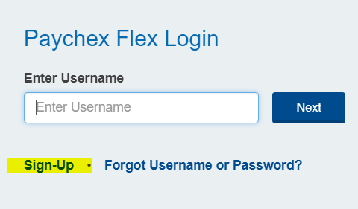
Prior to employment, or immediately after starting, an employee will create an account with Paychex by going to paychexflex.com and choosing the “Sign-up” option. Fill out all required information and verify your account.
If you have any issues setting up your account, get in touch with our Paychex Point of contact (POC) and have them assist you. The POC information is at the end of this document.

What you can do with Paychex
After you have successfully logged into Paychex, it is time to take advantage of this convenient human resources portal.
Through Paychex you will log your hours, request time off, sign up for your health benefits and much more. Continue reading for instructions on the various functions that can be performed in Paychex.
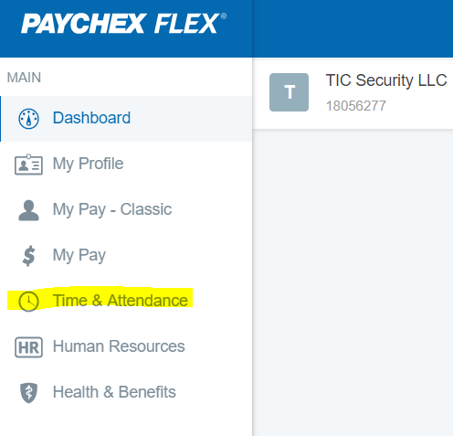
Logging Your Time
The most common task you will perform in Paychex is logging your time every week. To get started, log in and select “Time & Attendance” from your main menu, located in the top left corner of your screen.
From there, select the “Actions” option, the top left choice. A window will pop up where you will enter your hours for the current week.
Mandatory fields for the Time Sheet are the Date, Type of hours, Start Time, End Time and Job Costing. Make sure these fields are filled out for each entry.
The most common entry into the time sheet will be for working hours. You must have 2 entries for each work day, showing that you were clocked out for lunch. Below you can see the hours for October 26th start at 8am and continue until 12pm, then they resume at 1pm and stop at 5pm. This reflects an 8hr day with 1hr for lunch.
Other common entries in the time sheet will be sick time and vacation time. Specify either sick or vacation in the Type section, record 1 time range (shown as 8am-4pm in the example below) and select “TIC Vacation/Sick” in the Job Costing section.
As you enter your time, it is presented in a summary in the bottom right corner of the screen.

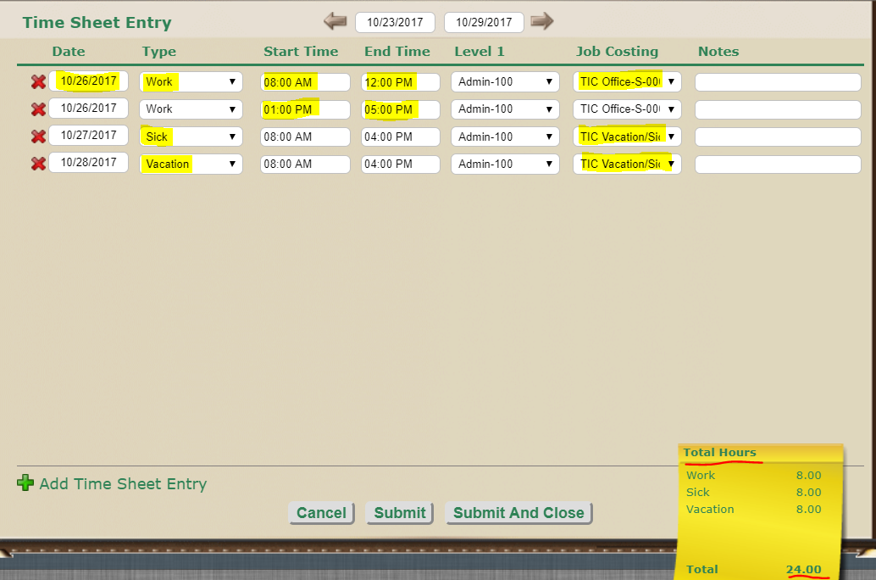

Requesting Time Off
At TIC Security, you begin to accrue vacation time when you start, but you are not eligible to use this until after your 90-day introduction period. When your time off becomes available to you, you can enter your requests into Paychex to be approved by your supervisor.
To get to the appropriate screen, select “Time and Attendance” from the main menu, then select “Time Off”, located on the right side of the screen. On the screen that pops up, select the “Request Time Off” option.
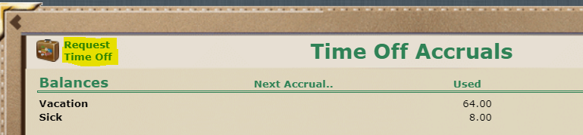
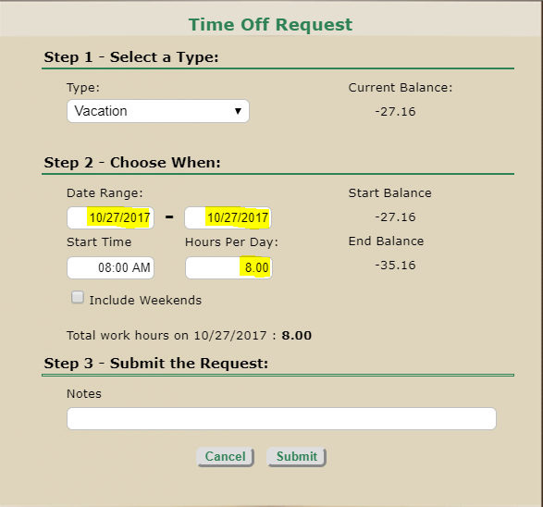
From there, another box will pop up. Make sure The Type is set to vacation, it should default to this anyway. Select your date range and how many hours of leave you will be using per day. On the right side of the box you can see your current balance of leave, as well as your starting and ending balance before and after your requested vacation time.
When you have set everything up click the submit button at the bottom. You can go back at any time to make changes and cancel requests.

Signing up for, or Rejecting Health Benefits
After your 90-day introductory period, any health benefits you sign up for will kick in. Your supervisor will notify you when it is time for you to select which, if any, benefits you would like to sign up for. TIC Security offers 3 medical plans to choose from, as well as the option to add a dental plan.
To sign up for benefits or to reject benefits, select the “Health & Benefits” option from the main menu and follow the prompts on the screens to follow.
Viewing your Compensation, Direct Deposit Details, your Deductions and your Tax Info
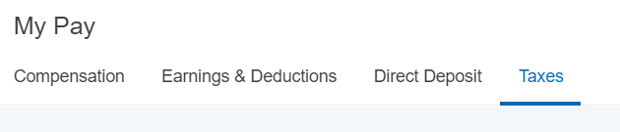
To view your compensation, direct deposit info, your deductions and earnings and your tax info, select the “My Pay” option on the main menu. This will bring you to a page with tabs at the top. Select the appropriate tab for the information that you want to view.

Viewing your Paystub
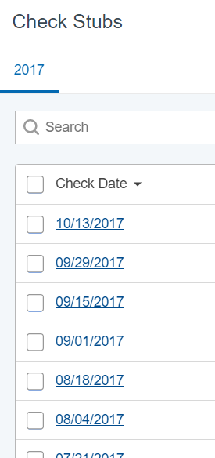
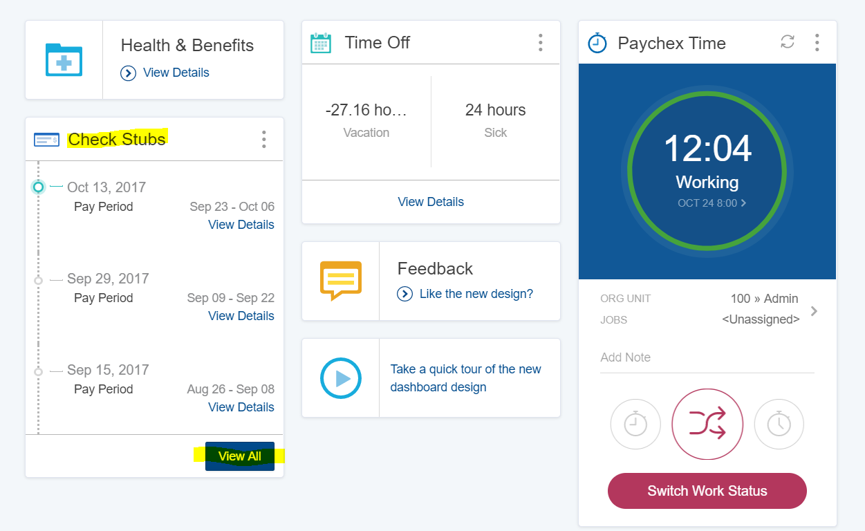
From your Dashboard (your home screen), there are several links displayed and a summary of your accrued leave as well. In the bottom left corner of the dashboard there is a link to view your time stubs. When you click it, a pop up box will show you all your check stubs, broken out by pay period. Click on whichever stub you want to view.

Completing Training Modules
Throughout your time here at TIC Security, there will be various training modules that you are required to complete. Your supervisor will notify you when you have required training to complete. This training can be found under the “Human Resources” tab of the main menu.
There are current no modules available for any employees as this is a new function that will be rolled out in the next few months. Instructions for how to complete your training will be posted when training modules become available.

Have questions about or issues with Paychex
If you’re having problems with Paychex, whether you can’t login, or you don’t know where to find certain information, feel free to reach out to our Human Resources Representative:
Kelsee Zyzak
(240) 388-5506
Kelsee.Zyzak@TICSecurity.com

